**Country class:**

package com.afrin.springrest.model;

public class Country {

private String code;

private String name;

// Constructors

public Country() {}

public Country(String code, String name) {

this.code = code;

this.name = name;

}

// Getters and Setters

public String getCode() {

return code;

}

public void setCode(String code) {

this.code = code;

}

public String getName() {

return name;

}

public void setName(String name) {

this.name = name;

}

}

**CountryController:**

package com.afrin.springrest.controller;

import com.afrin.springrest.model.Country;

import org.springframework.web.bind.annotation.*;

import java.util.ArrayList;

import java.util.List;

@RestController

public class CountryController {

List<Country> countries = new ArrayList<>();

public CountryController() {

countries.add(new Country("IN", "India"));

countries.add(new Country("US", "United States"));

countries.add(new Country("CN", "China"));

countries.add(new Country("FR", "France"));

}

// Get a country based on user input from URL

@GetMapping("/countries/{code}")

public Country getCountryByCode(@PathVariable String code) {

for (Country country : countries) {

if (country.getCode().equalsIgnoreCase(code)) {

return country;

}

}

throw new RuntimeException("Country not found with code: " + code);

}

}

**OUTPUT:**

**CHINA**

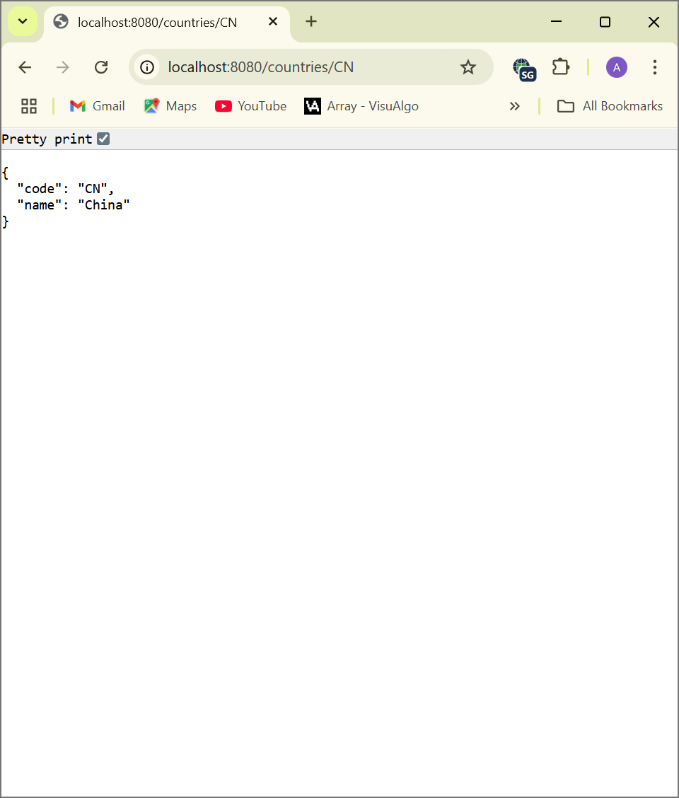

**INDIA**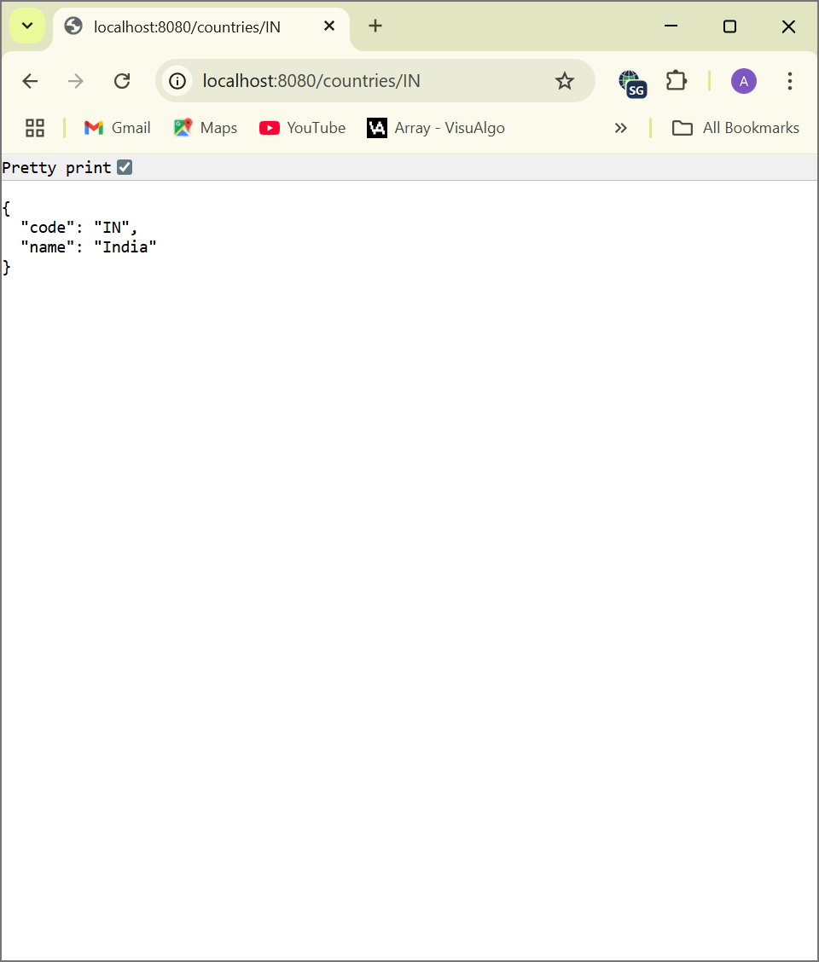

**US**

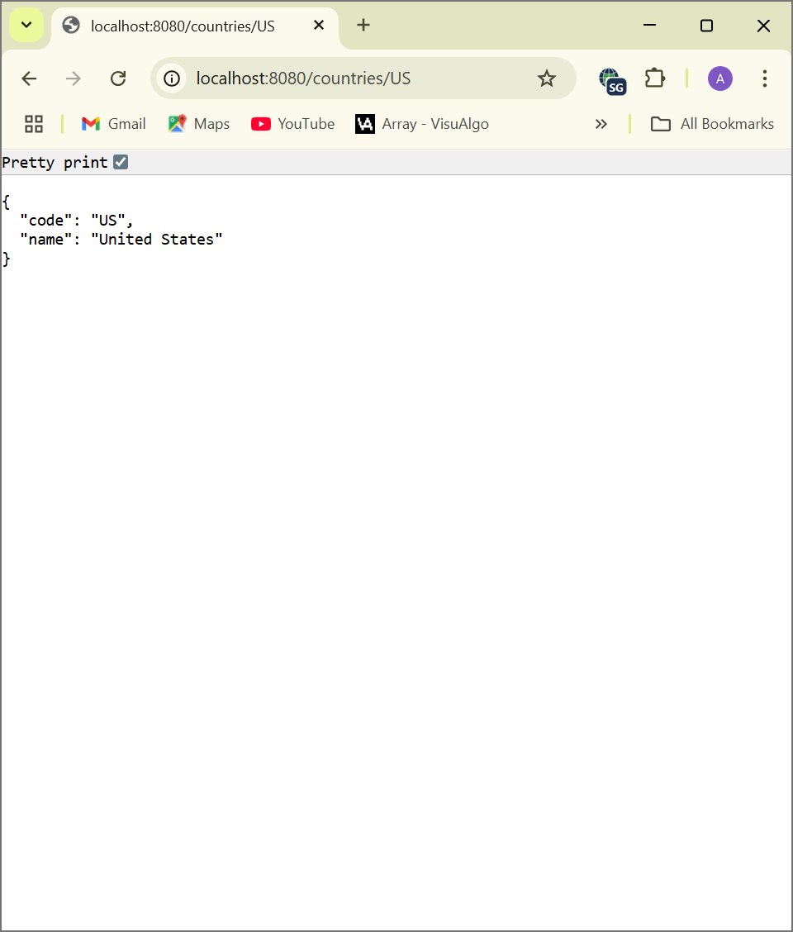

**FRANCE:**

